

|  |  |
| --- | --- |
| **Welcome To**  **Feis Buddy**  **A MOBILE APPLICATION**  Keep yourself well-informed on the North American Irish Dance Championships, all in one place! | **Download Now For Getting Instant Updates!**  Get real-time information on event schedules, results, and more. You won’t miss any crucial moments of the event by having this app. |

|  |  |
| --- | --- |
|  | **About**  **Feis Buddy**  FEIS Buddy is an event communication mobile application that keeps all stakeholders up-to-date about events held under the North American Irish Dance Championships (NAIDC) platform. With this app, you can keep yourself well-informed of exact schedules, competitor lists, results, ballroom announcements, and more. The app enables event organizers to share accurate and timely event-related information on the app with users. Users can join the event’s social media profiles and get in touch with the event organizers.  We make communication easier! |

|  |  |  |
| --- | --- | --- |
| **Enjoy The Dance Championships**  The app **makes the dance championships more**  **exciting,** letting you enjoy the event to the maximum  with its help. | | |
| **Event List**  Be aware of all the events happening at the Dance Championships. | **Competitors List**  View the complete list of competitors - their names, dates & time, and location. | **Results**  Get instant updates on the competition results - status, category, date & time, and winner’s name. |

|  |  |
| --- | --- |
| **North American Irish Dance Championships**  The North American Irish Dance Championships is the premier Irish dance competition held annually in North America. The NAIDC creates an excellent opportunity for dancers, regardless of their ages and skill levels, to participate in the contest and perform against the best in the continent. The NAIDC is also a platform where Irish and American cultures are celebrated.  The FEIS Buddy app saves all event stakeholders, including dancers, attendees, and organizers, from the hassle of physically going to get information on the NAIDC by keeping them updated here. |  |

**Scan The QR Code And Gain Access to The App**

Once scanned, you will be on the download page; it’s that easy!



|  |  |
| --- | --- |
|  | **Get In Touch.**  Subscribe to the Newsletter to Get the Latest Updates. |

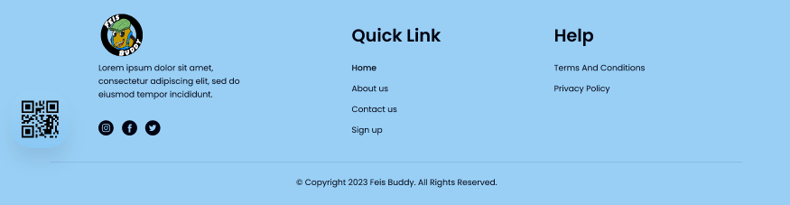

FEIS Buddy is an event communication mobile application that keeps all stakeholders of the NAIDC platform updated about the associated events.